



Computer Communications 27 (2004) 1330–1340

www.elsevier.com/locate/comcom

Abstract

A scalable architecture for end-to-end QoS provisioning

Spiridon Bakiras*, Victor O.K. Li

Department of Electrical and Electronic Engineering, The University of Hong Kong, Pokfulam Road, Hong Kong, China
Received 23 September 2003; revised 18 March 2004; accepted 13 April 2004
Available online 4 May 2004

The Differentiated Services (DiffServ) architecture has been proposed by the Internet Engineering Task Force as a scalable solution for
providing end-to-end Quality of Service (QoS) guarantees over the Internet. While the scalability of the data plane emerges from the
deﬁnition of only a small number of different service classes, the issue of a scalable control plane is still an open research problem. The initial
proposal was to use a centralized agent, called Bandwidth Broker, to manage the resources within each DiffServ domain and make local
admission control decisions. In this article, we propose an alternative decentralized approach, which increases signiﬁcantly the scalability of
both the data and control planes. We discuss in detail all the different aspects of the architecture, and indicate how to provide end-to-end QoS
support for both unicast and multicast ﬂows. Furthermore, we introduce a simple trafﬁc engineering mechanism, which enables the more
efﬁcient utilization of the network resources.
q 2004 Elsevier B.V. All rights reserved.
Keywords: Admission control; Differentiated services; Quality of service; Resource management; Trafﬁc engineering

1. Introduction

In the past few years, the dramatic increase in the
capacity of the Internet core, and the development of
powerful compression techniques, have allowed the
deployment of new applications such as Internet telephony,
video-conferencing, streaming audio/video, etc. These
applications are called real-time, since they require the
periodic and timely delivery of the content from the source
to the destination. Clearly, the traditional best-effort service
that is provided in the current Internet cannot offer
an acceptable level of service quality to this type of
applications. To address this problem, the Internet Engi-
neering Task Force (IETF) has proposed the Differentiated
Services (DiffServ) architecture [1] as a scalable solution for
providing end-to-end Quality of Service (QoS) guarantees
over the Internet. The scalability issue is of outmost
importance, since, in the future, the number of ﬂows that
will require some QoS guarantees is expected to be very
large. Consequently, a core router should be able to
accommodate thousands of QoS-sensitive ﬂows at any
time instant.

* Corresponding author. Tel.: ю 852-2857-8487; fax: ю852-2559-8738.
E-mail addresses: sbakiras@eee.hku.hk (S. Bakiras); vli@eee.hku.hk
(V.O.K. Li).
0140-3664/$ - see front matter q 2004 Elsevier B.V. All rights reserved.
doi:10.1016/j.comcom.2004.04.002

The basic idea of the DiffServ architecture is that only
edge routers should manage trafﬁc on a per ﬂow basis. Core
routers should not keep any kind of per ﬂow state, and
should process trafﬁc on a much coarser granularity. At the
data plane this goal is achieved by specifying different Per
Hop Behaviors (PHBs), where packets belonging to the
same PHB form a Behavior Aggregate (BA) and receive
identical service at the core routers. Speciﬁcally, the edge
routers will be equipped with ﬂow classiﬁers, policers, and
markers that will properly mark the incoming packets by
setting a number of bits on the DiffServ Codepoint (DSCP)
[2] ﬁeld of the IP packet header. The DSCP value will
indicate the corresponding PHB, and the core routers will
forward the packets based on their DSCP value (by utilizing
several scheduling and buffer management techniques).
The IETF has currently speciﬁed two different PHBs.
The Expedited Forwarding (EF) PHB [3] offers the
equivalent of a leased line (i.e. low delay, loss, and jitter)
between a source and a destination. This is accomplished
by giving EF trafﬁc strict priority over the traditional best-
effort trafﬁc inside the DiffServ domain. However, each
ﬂow has to specify in advance the required bandwidth so
that the appropriate resources may be reserved inside the
network. In addition, the maximum burst size that is allowed
is equal to two Maximum Transmission Units (MTUs).

S. Bakiras, V.O.K. Li / Computer Communications 27 (2004) 1330–1340

1331

The edge routers will police each ﬂow, and the non-
conforming packets will either be dropped or shaped. The
Assured Forwarding (AF) PHB group [4] does not offer
hard QoS guarantees, but instead deﬁnes four different AF
classes with three different levels of drop precedence within
each class. Each AF class is assigned a certain amount of
bandwidth at each node, and when the amount of trafﬁc
exceeds this bandwidth, packets will be dropped according
to their drop precedence value.
While the scalability of the data plane emerges from the
deﬁnition of only a small number of PHBs, the issue of a
scalable control plane is still an open research problem. The
initial proposal was to use a centralized agent, called
Bandwidth Broker (BB) [5], to manage the resources within
each DiffServ domain and make local admission control
decisions. The centralized approach removes the burden of
admission control from the core routers, but there might be
some scalability considerations if the BB has to process
thousands of requests per second. Moreover, this approach
has certain disadvantages that are inherent to any centra-
lized architecture.

† The links around the BB will become very congested
when the trafﬁc load from the signaling messages is high.
† The BB must maintain per ﬂow information about every
ﬂow that is currently active inside its domain.
† The BB is a single point of failure (i.e. undesirable in
reliability considerations).

In this article, we propose an alternative decentralized
architecture, where the local admission decisions are made
independently at the edge routers of each domain. The BB in
each domain is only responsible for periodically updating
the allocation of the resources inside the domain, according
to some measurements of the trafﬁc load at the edge routers.
We discuss in detail all the aspects of the proposed
architecture (i.e. intra- and inter-domain routing, admission
control, packet forwarding, etc.), and indicate how to
provide end-to-end QoS support for both unicast and
multicast ﬂows. Furthermore, we introduce a simple trafﬁc
engineering mechanism, which enables the more efﬁcient
utilization of the network resources.
The remainder of this article is organized as follows.
In Section 2 some related work on DiffServ resource
management is presented. In Section 3 we give the details of
the proposed architecture, and also discuss various
implementation issues. In Section 4 the results of the
simulation experiments are presented, while Section 5
concludes our work.

2. Related work

The standardization of the DiffServ architecture by the
IETF triggered the initiation of several projects, which aim
to provide DiffServ-based QoS guarantees over the Internet.

The largest of these projects is the Internet2 project, which
involves over 200 universities, corporations, and other
organizations worldwide. The main objective of the
Internet2 QBone initiative [6] is to build an experimental
testbed for providing end-to-end QoS guarantees in a
scalable manner. Their approach on resource management
follows the initial proposal of a centralized BB, which is
responsible for managing the resources within a DiffServ
domain, and performing intra-domain admission control.
For end-to-end resource reservations, inter-BB signaling is
required between the BBs of adjacent domains.
One direction towards improving the scalability of the
resource management is based on aggregated resource
reservations between DiffServ domains. The BB is still the
centralized agent responsible for resource reservation, but
the scalability is improved by reserving resources for
aggregate trafﬁc between different domains. In Ref. [7] a
two-tier model is introduced, where each domain is assumed
to have long-term bilateral agreements with each of its
neighbors, specifying the amount of trafﬁc that will be
exchanged between them. Whenever there is an increase in
the trafﬁc between two domains, the BBs will re-negotiate
and make new agreements. In Ref. [8] a Clearing House
architecture is proposed, where multiple basic domains are
clustered to form a logical domain. In this way, a
hierarchical tree is created, where the BB of the logical
domain is responsible for resource reservation across the
basic domains. The BBs at the basic domains forward only
aggregation of inter-domain requests to the BB of the
logical domain, thus enhancing the scalability of this
architecture.
Alternatively, an approach based on the Multiprotocol
Label Switching (MPLS) [9] architecture has also been
considered in Refs. [10,11]. In these two architectures,
reservations for aggregate trafﬁc are made between pairs of
edge routers on speciﬁc Label Switched Paths (LSPs) inside
the domain. All the QoS-sensitive ﬂows will then follow the
appropriate LSPs, in order to receive the requested QoS.
The work in Ref. [11] is introduced as part of the Trafﬁc
Engineering for Quality of Service in the Internet at Large
Scale (TEQUILA) project.

3. An architecture for end-to-end QoS provisioning

In this section we introduce an architecture for DiffServ-
based networks, which enhances the scalability of both the
data and control planes. The goal is to push most of the
functionality to the edge of the network, and maintain a
simple core, which only performs a standard packet
forwarding function. Our assumption is that the Internet
consists of several independently administered DiffServ
domains that are interconnected in order to provide
global connectivity. One typical example is shown in
Fig. 1, where the sender рSЮ and the two receivers (R1 and R2)
are interconnected through three different domains.

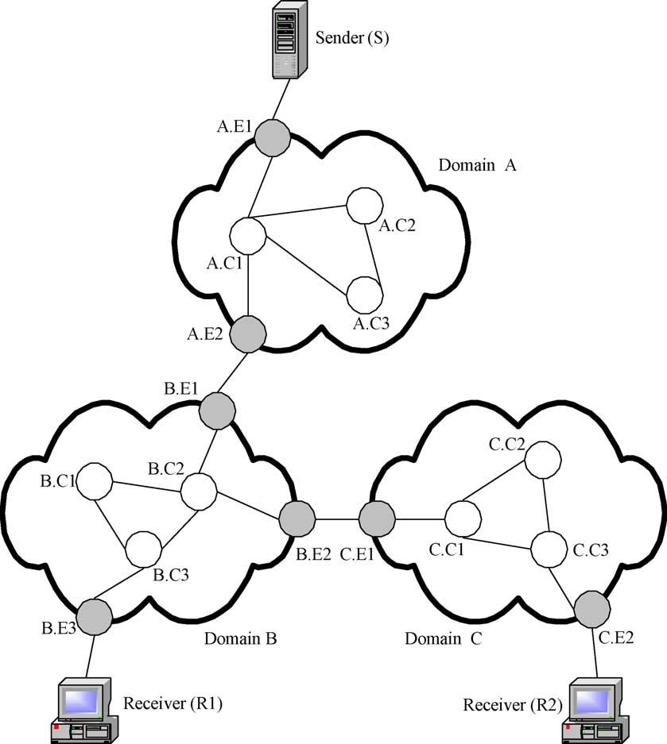

1332

S. Bakiras, V.O.K. Li / Computer Communications 27 (2004) 1330–1340

Fig. 1. The Differentiated Services architecture.

Each DiffServ domain consists of a BB (not shown in the
ﬁgure), and the core and edge routers. The BB will
periodically exchange control messages with the edge
routers for the purpose of resource management.

3.1. Intra-domain routing

Routing is the process of correctly identifying the next
hop at each node (router) so that a packet will be able to
reach its ﬁnal destination. In this work we focus on intra-
domain routing, and assume that all the DiffServ domains
use a standard inter-domain routing protocol, such as the
Border Gateway Protocol (BGP) [12], to exchange reach-
ability information with their neighbor domains. All the
edge routers in each domain will participate in this
information exchange.
Routing with QoS guarantees requires the reservation
of enough resources along the path from the source to the
destination. Therefore, unlike best-effort trafﬁc routing, a
path has to be established in advance between the source
and destination nodes, and all the packets should follow
the same path. In our architecture, we adopt a source
routing scheme, where the ingress router of the domain
will identify the complete path towards an egress router.

Speciﬁcally, during the initialization of the network, the
BB will pre-compute k different paths to carry the trafﬁc
between each pair of edge routers, and it will distribute
this information to all the routers in its domain. In the
simulation experiments presented in Section 4, we used
the well known k-shortest path algorithm [13] for the
path selection, where the hop count was used as the
link metric.
The source routing approach was adopted for several
reasons: (i) it facilitates fast packet forwarding which will
be further discussed in Section 3.2, (ii) it follows the general
principles of the DiffServ architecture, by completely
isolating the core routers from the admission control
procedure, and (iii) it provides the means for implementing
trafﬁc engineering mechanisms inside the domain.
Finally, we assume that a standard link state routing
protocol, such as OSPF, operates inside each domain, in
order for the edge routers to advertise their routes to other
networks, and also to exchange information with all the core
routers regarding link or node failures. In other words, our
intra-domain routing protocol will operate on top of any link
state protocol, and the ingress routers of the domain will use
the existing link state database to identify the corresponding
egress router where a packet should be forwarded to.

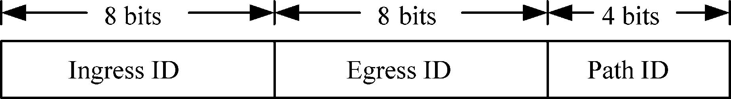

S. Bakiras, V.O.K. Li / Computer Communications 27 (2004) 1330–1340

3.2. Packet forwarding with IPv6

The slowest process in the forwarding path of an IP

1333

router is the multi-ﬁeld classiﬁcation and routing procedure.
When a packet is received at a router, the next hop is
decided by looking into several ﬁelds on the IP header (e.g.
IP addresses, TCP/UDP port numbers, etc.), and then
ﬁnding the appropriate entry at the local routing table. This
operation will be even more complicated for QoS-sensitive
ﬂows, since their packets should follow exactly the same
path. Clearly, this procedure will become the bottleneck in a
multi-Gbps router.
The IPv6 packet header contains a new 20-bit ﬁeld,
which does not exist in the earlier IPv4, called ﬂow label.
Using this ﬁeld in the context of a source routing
architecture, enables us to increase considerably the speed
of the forwarding path. As we mentioned earlier, for each
pair of edge routers inside a domain, there will be k pre-
computed paths connecting them. We may then assign one
ﬂow label value to each one of these paths, and construct
new (much smaller) routing tables inside the core of the
domain, based only on ﬂow labels. We should emphasize
that the ﬂow label in our approach is not related to the
traditional deﬁnition of a ﬂow (i.e. a connection between a
certain source – destination pair). Instead, we use the ﬂow
label ﬁeld in the IP header, in order to identify a unique path
within an AS domain. As a result, any path within a domain
will be assigned a speciﬁc ﬂow label value, and all the
packets (from any packet ﬂow) that have to follow this path
will be marked with that exact ﬂow label value. Therefore,
the unicast routing table within a domain will be static, and
its maximum size will be equal to the total number of paths
that we choose to identify. Furthermore, during the resource
reservation procedure, the ingress router will select one of
the k paths for each new ﬂow, and then mark all the packets
that belong to this ﬂow with the corresponding ﬂow label
value.
An alternative method would be to use the routing header
option in IPv6, since it provides exactly the same
functionality (i.e. source routing). The reason why we did
not choose this option is due to the large overhead that it
introduces. Each IPv6 address entry is 16 bytes, and for a
multi-hop path this approach could increase substantially
the protocol overhead (especially for small packet sizes). In
addition, using the routing header option does not help in the
case of multicast communication. In the following para-
graphs we will indicate how the ﬂow label approach may be
exploited to facilitate multicast routing.
Notice, that our forwarding scheme is similar to the
MPLS architecture, but it does not require inter-router
signaling as in the case of the label distribution protocol
(LDP) in MPLS networks. The BB will be the centralized
agent responsible for distributing the routing tables to the
domain routers. In particular, after the BB has selected the k
paths for each pair of edge routers, it will send the
appropriate routing table entries to all the routers in
Fig. 2. Flow label assignment.

the domain. These entries will be in the form of
kflow_id; link_idl; where link_id indicates the outgoing
interface where the packet should be forwarded to. Having a
centralized agent distribute all the routing information does
not affect the scalability of the architecture, since this
information will be distributed only once (at the initializa-
tion of the network) and will be updated only if a new link or
router is introduced in the topology.
One example of how to assign ﬂow labels to the different
paths inside a domain is depicted in Fig. 2. With this
assignment, for instance, we are able to identify a maximum
of 16 different paths between any pair of 256 edge routers.
To further illustrate the concept of ﬂow-based routing,
consider the edge routers B:E1 and B:E3 in domain B
(Fig. 1). Assume that the ID of B:E1 is 0, and the ID of B:E3
is 2. There are exactly two paths connecting these routers
(through B:C2 ! B:C3 or B:C2 ! B:C1 ! B:C3), and
suppose we assign them the IDs 0 and 1, respectively.
These two paths may then be represented by the ﬂow
label values ‘0.2.0’ and ‘0.2.1’. As a result, if B:C2
receives a packet with a ﬂow label value 0.2.1, it will
forward it towards B:C1 and not towards the shortest path
(i.e. through B:C3).
For multicast communication, packet forwarding is
slightly more complicated, but we may still utilize the
above ﬂow-based routing mechanism to maintain a scalable
forwarding path. Let us consider Fig. 1 again, and assume
that receivers R1 and R2 wish to join a multicast group
created by the sender S in domain A: Suppose node R1 joins
the multicast group ﬁrst. Then, B:E1 will send a control
message to the core routers B:C2 and B:C3 in the form of
kINSERT ; MG; 0:2:0l; or else “if you see a packet destina-
tion address MG; use ﬂow label 0.2.0 to forward it”. This
message will create an entry in a local multicast routing
table inside the core routers. When R2 joins the group, the
message kINSERT ; MG; 0:1:0l will be sent to B:C2; forcing
it to forward the packets towards both B:C3 and B:E2: If a
node decides to leave the multicast group, similar DELETE
messages will be sent, if necessary.

3.3. End-to-end admission control

Resource reservation is an essential part of any network
that provides QoS guarantees, and an appropriate signaling
protocol is necessary in order to perform this function. In
our architecture, the receiver nodes will initiate the
signaling procedure for the resource reservation, while the
intermediate ingress routers will be responsible for admit-
ting or rejecting the reservation requests. In the following
paragraphs we illustrate how admission control may be

1334

S. Bakiras, V.O.K. Li / Computer Communications 27 (2004) 1330–1340

performed across multiple DiffServ domains for the case of
unicast and multicast ﬂows.
Let us consider unicast ﬂows ﬁrst, and assume that R1
(Fig. 1) wishes to receive some QoS-sensitive data from the
sender S at domain A: Then, the end-to-end admission
control will be performed as follows (with an RSVP-like
signaling protocol).

(1) R1 will send a PATH message towards S; indicating the
required amount of bandwidth b:
(2) The PATH message will reach B:E1 which will be the
ingress router for that particular ﬂow. Therefore, it will
check whether there are enough resources to carry this
ﬂow towards B:E3: The details of the admission control
decision will be discussed in Section 3.4, where we
introduce the trafﬁc engineering mechanism.
(3) If there are not any sufﬁcient resources, the request will
be rejected. Otherwise one of the k available paths
towards B:E3 will be selected, and the PATH message
will be forwarded towards S:
(4) The PATH message will reach A:E1 which will also
perform the admission control as in steps (2) and (3).
(5) If this request can be accommodated, A:E1 will
forward the PATH message to the source node S:
(6) If S wishes to establish this connection, it will send the
RESV message back to R1:
(7) While the RESV message travels back to the destina-
tion node, all the intermediate edge routers will
conﬁgure their trafﬁc shapers, policers, and markers
to account for the new connection.

The signaling procedure for multicast ﬂows is essentially
identical to the one described above, with only a few minor
additions. We assume that a multicast group is identiﬁed by
the pair рS; MGЮ; i.e. the IP address of both the source and
the multicast group. For multicast groups where any
receiver can also be a sender, we assume that only one
node is allowed to create the multicast group, and this node
will be the designated source. This is a very reasonable
assumption, which greatly simpliﬁes the routing of the
signaling messages when new nodes join a multicast group.
Going back to our example, let us consider the case where
node R1 joins the multicast group initiated by node S: The
signaling message ﬂow will then be as follows.

(1) R1 will send a PATH (or join) message towards S;
indicating the required amount of bandwidth b:
(2) If R1 may also be a sender (i.e. in multipoint-to-
multipoint communication), B:E3 will reserve the
appropriate resources towards B:E1; and forward the
PATH message towards S:
(3) Steps (2) – (7) from the unicast case will be performed
in the same manner. In the case of multipoint-to-
multipoint communication, both the ingress and egress
routers will perform admission control, since the
multicast data may ﬂow in both directions.

(4) A:E1; A:E2; B:E1 and B:E3 will send the appropriate
control messages to the core routers of their domains,
in order to set the corresponding entries in the multicast
routing tables (as described in Section 3.2).

If R2 decides to join the multicast group, the same steps
as above will take place. However, as soon as B:E1 receives
the PATH message, it will not forward it to S; since it
already has a reservation entry for that particular multicast
address. Instead, it will send the RESV message back to R2;
given that there are enough resources to carry the multicast
trafﬁc towards B:E2:
Notice, that in the multipoint-to-multipoint scenario we
have assumed that only one member is allowed to send
packets at any given time. If this is not the case (i.e. if all
members are allowed to transmit simultaneously), then the
PATH messages will have to travel always back to the
initiator of the group (node S in our case), in order to reserve
additional bandwidth for each new member. Also, we have
made the implicit assumption that the ingress routers
corresponding to the initiator of the group will act as the
core nodes of the multicast tree inside their own domain. In
our example, since node S initiated the multicast group,
A:E1 will be the core of the tree in domain A; B:E1 will be
the core in domain B; and C:E1 will be the core in domain C:
In other words, if R1 wishes to send a packet to the multicast
group, this packet will be forwarded towards B:E1; and each
router along the path will forward it to all the corresponding
interfaces (based on the local multicast routing table),
except the one that the packet was received from. Clearly,
this is not the optimal way to distribute the multicast trafﬁc,
but it simpliﬁes greatly the multicast routing protocol, since
it avoids the construction of a separate multicast tree for
each member of the group.
It is evident that our model is using the per-ﬂow reservation
paradigm, which is the basis of the IntServ architecture.
However, our approach overcomes the scalability problem of
IntServ, by (i) eliminating the core routers from the resource
reservation procedure, and (ii) decentralizing the resource
reservation procedure. Moreover, the resource reservation
phase is completed by the exchange of only two messages.
The ﬁrst message рPATHЮ is sent from the receiver towards
the sender, and is followed by the reply message (RESV or
reject) which is sent back to the receiver. These messages are
only intercepted by the corresponding edge routers (i.e.
ingress and egress) of each domain, and are not processed at
all by any of the core routers. The advantages of this
decentralized architecture may be summarized as follows.

† The signaling overhead for connection set up is spread
across multiple links, avoiding the congestion of the links
around the centralized BB.
† The BB does not need to maintain per ﬂow information
about every ﬂow that is currently active inside its domain.
This information will be distributed across the edge routers
of the domain.

S. Bakiras, V.O.K. Li / Computer Communications 27 (2004) 1330–1340

1335

† It offers a scalable solution for dynamic connection set up
with very fast response time (equal to the round-trip delay
between the source and the destination).
† A temporary failure of the BB does not affect the
functionality of the domain, since the admission control
may be performed based on the current resource allocation
vector. The failure of an edge router has no effect, since no
trafﬁc should be routed through this node.
† The core routers are not involved at all in the resource
reservation procedure.
† The edge routers are able to dynamically route the best-
effort trafﬁc through paths that are possibly not congested,
i.e. paths for which the edge router has reserved only a
small portion of the allocated bandwidth.

Before we continue, let us discuss brieﬂy the amount of
state information that needs to be stored in the different
routers of each domain. First, the ingress routers will
maintain per ﬂow state about all the active QoS ﬂows for
which they have an entry in the reservation database.
Speciﬁcally, they will keep the following pieces of
information: (i) the source and destination IP address and
port number, (ii) the corresponding egress router IP address,
(iii) the assigned ﬂow label value, and (iv) the amount of
bandwidth reserved.
The egress routers between two domains (e.g. nodes
A:E2 and B:E2 in Fig. 1) do not need to keep any per ﬂow
state. Instead, they will keep some information about the
aggregate amount of QoS trafﬁc that leaves the domain
through that particular node. This information is important,
since the egress routers will need to shape the QoS trafﬁc so
that it does not exceed the total amount of reserved
bandwidth towards other domains.
Finally, the egress routers located near the clients (i.e.
B:E3 and C:E2), which are often referred to as leaf routers,
will also need to maintain per ﬂow state about all the clients
that are directly connected to them. This is not required for
the provisioning of QoS guarantees, but it is necessary in
order to implement soft state resource reservation. In
particular, the receiver nodes will periodically send refresh
messages to their local leaf router, which will verify the
validity of the reservation. If the leaf router does not receive
a refresh message within a certain timeout period, it will
send a message to the corresponding ingress router to
release the necessary resources.

3.4. Trafﬁc engineering

Trafﬁc engineering is the process where the routes
between any two endpoints of a certain domain are
dynamically selected, according to the current trafﬁc load,
so as to optimize the utilization of the network resources. In
our architecture, the BB will be responsible for periodically
updating the allocation of the resources inside the domain,
according to some measurements of the trafﬁc load at the
edge routers. When the allocation of resources is completed,

all the edge routers will be able to make instantaneous and
independent admission control decisions for new connec-
tion requests.
Let us consider the following model for a generic
DiffServ domain.

† There are M edge routers in the domain.
† Every edge router will maintain the exact information
about the network topology of the domain.
† There are N ј MрM 2 1Ю different router pairs to which
we shall refer to as Source-Destination (SD) pairs.
† For each SD pair рi; jЮ there are k pre-computed paths.

The BB will periodically (e.g. every T minutes) allocate
a certain amount of bandwidth on every link of the network
topology to each one of the M edge routers. This
information will be distributed to the corresponding edge
routers, and will enable them to make independent
admission control decisions. In other words, each router
will see the same network topology, but with different link
capacities, which may be used entirely by itself. If a new
reservation request arrives for SD pair рi; jЮ; the ingress
router i will select the shortest of the k available paths
which can satisfy the request. A similar shortest path tree
method may be used for the case of multicast ﬂows.
In order for the BB to allocate the resources in a more
efﬁcient manner, it will need some information regarding
the trafﬁc load requirements between the different SD pairs.
We assume that the source node of each SD pair рi; jЮ will
keep track of the following variables in order to measure the
trafﬁc load towards the destination j :

† Total number of requests, r_{ij}:
† Total amount of bandwidth requested, b_{ij}:
† Total holding time for completed connections, t_{ij}:
† Total number of completed connections, c_{ij}:
Whenever a new request arrives at a certain node i; the
corresponding r_{ij}will be incremented by one, while the
requested bandwidth b will be added to b_{ij}: If a connection is
terminated, its holding time will be added to t_{ij}; and c_{ij}will
be incremented by one. Every time interval T ; the BB will
poll every edge router i; and it will ask for the following two
pieces of information: (i) the current amount of resources
reserved on each link рl; mЮ; {x_{i}рl; mЮ}; and (ii) the required
amount of additional bandwidth w_{ij}(if any) towards
each destination j: After receiving all the information, the
BB will run an algorithm which will calculate the new
values of {x_{i}рl; mЮ}:
For the calculation of w_{ij}we may model each SD pair as
an M/M/m/m queueing system. We assume that new
requests arrive according to a Poisson process with rate l;
and that the system can accommodate up to m concurrent
connections. The service time for each connection is
exponentially distributed with mean 1=m: Using Erlang’s
B formula, we may calculate the blocking probability for

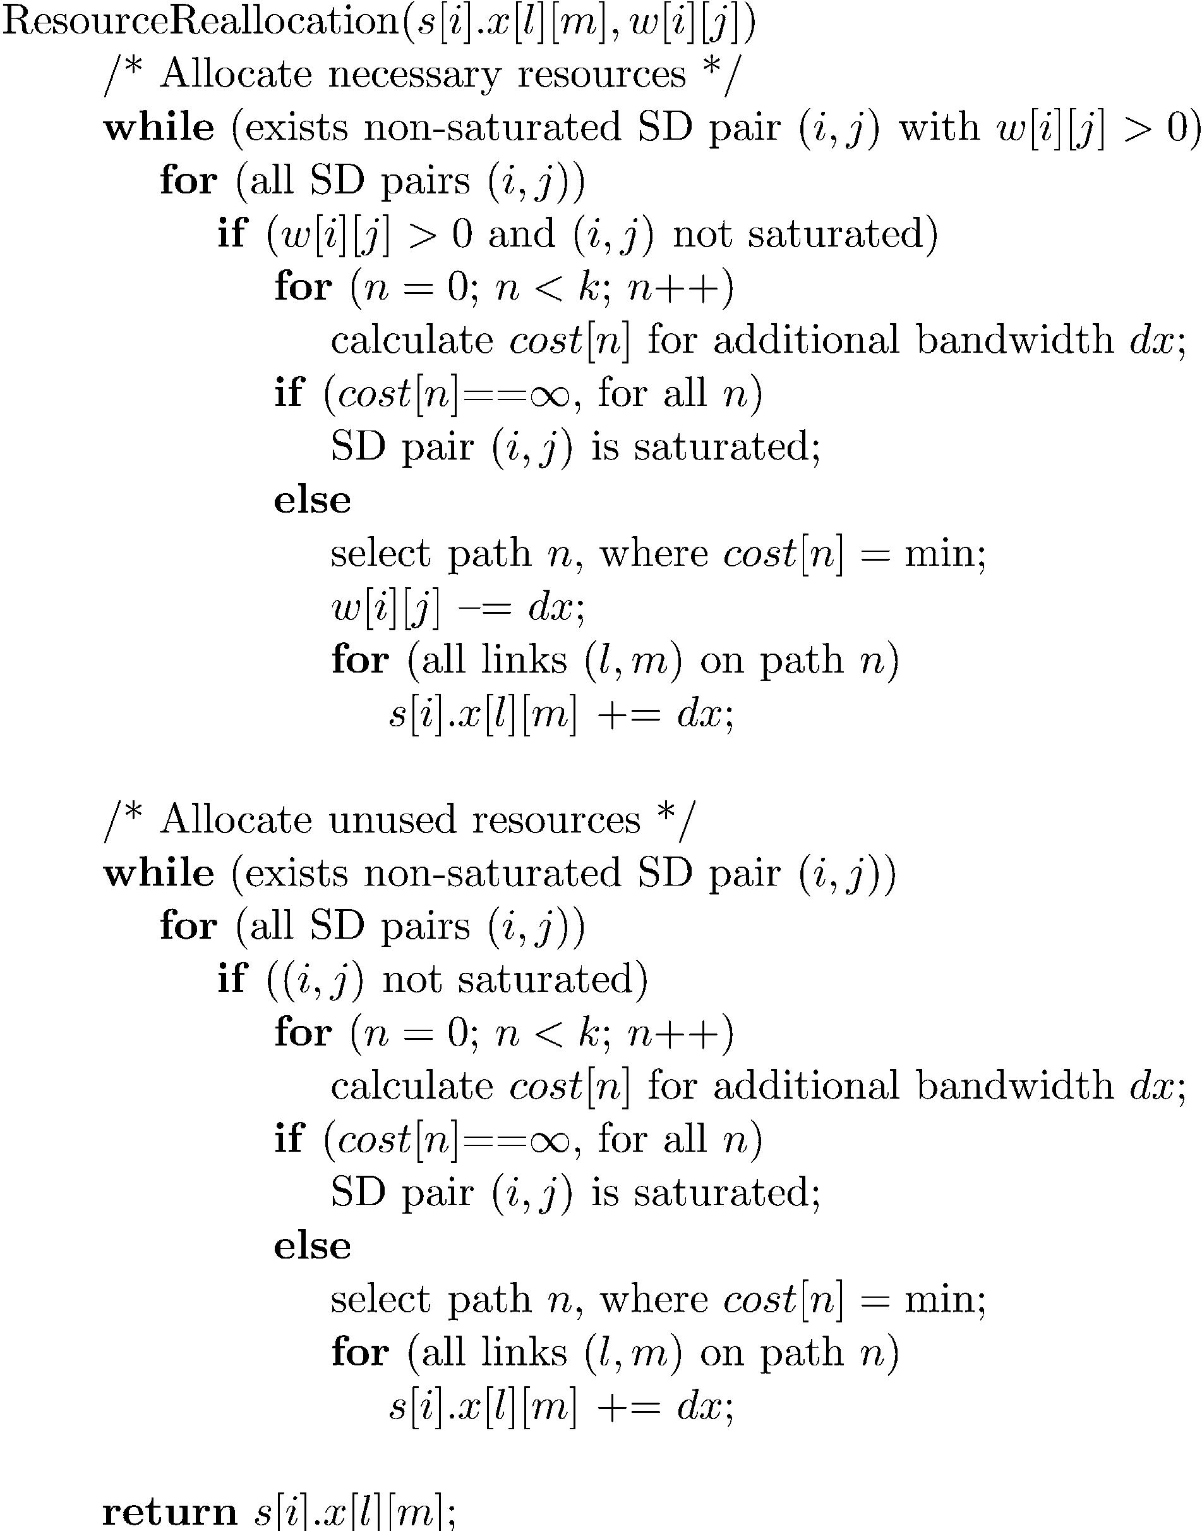

1336

new requests as follows
рl=mЮ^{m}=m!

S. Bakiras, V.O.K. Li / Computer Communications 27 (2004) 1330–1340

p_{m}ј
X
kј0
рl=mЮ^{k}=k!

In our case, l ј r_{ij}=T and 1=m ј t_{ij}=c_{ij}: Then, we can
calculate the smallest value of m for which the blocking
probability is less than, for example, 1%. Therefore, the
total trafﬁc load for SD pair рi; jЮ will be equal to mb_{avg};
where b_{avg}ј b_{ij}=r_{ij}is the average amount of requested
bandwidth. Assuming that the current amount of reserved
resources for SD pair рi; jЮ is s_{ij}; w_{ij}will be given by w_{ij}ј
max{0; mb_{avg}2 s_{ij}}:
We understand that the M/M/m/m model is not entirely
accurate, but we believe that it provides a very good
approximation for predicting the amount of required
bandwidth between a pair of edge routers. For example, it
is generally acknowledged that the arrival of new requests
from a large population size (e.g. for voice or video) may be
modeled as a Poisson process. Also, the holding times for
voice calls have long been considered as exponential. For
video calls (e.g. video-conference, streaming video) the
exponential assumption is not so accurate, but in the general
case the holding times will consist of many short calls (e.g. a
short video clip, a videophone application) with only a small
percentage of longer calls (e.g. a two-hour movie). In any
case, the exponential holding time assumption provides a
good approximation and, most importantly, allows us to use
a simple formula for calculating the amount of required
resources. Using a more elaborate queueing model would
increase the complexity of the trafﬁc engineering module,
while the return in terms of accuracy would be uncertain.
For the resource reallocation procedure we use a simple
greedy algorithm (Fig. 3) which may be summarized as
follows. We add, in a round-robin manner, a very small
amount of bandwidth dx to each SD pair with w_{ij}. 0: This
amount of bandwidth will be added to the path n which
minimizes a certain cost function. The above procedure will
continue until all SD pairs have either w_{ij}# 0 or have
become saturated (i.e. no more resources can be allocated to
them). The cost function that we used was the average
number of packets in an M/M/1 system [14], given by

Fig. 3. The resource reallocation algorithm.

For example, two neighbor domains may choose to limit the
amount of trafﬁc that is exchanged between them. This may
be realized by limiting the capacity of the inter-domain link
in the resource management algorithm. Another example is
the more permanent connection set up of a Virtual Private
Network (VPN). This may also be realized by setting up
these connections in advance, and then limiting the capacity
of the corresponding links.
Finally, we should note that our architecture is easily
applied to the Relative DiffServ model as well. Instead of
calculating the values of x_{i}рl; mЮ for the EF class only,
different values may be assigned for other service classes as
well. The edge routers will then be able to reserve resources
for any service class requested by the end-user. In other
words, each additional service class may be treated (from
the resource management point of view) exactly as the EF

cost_{n}ј
X

рl;mЮ
F_{lm}
C_{lm}2 F_{lm}
class. The relative service (e.g. delay, bandwidth) received
by each class will be determined by the packet scheduling
algorithm that is implemented at the routers, and is beyond

where рl; mЮ are the links that belong to path n; F_{lm}is the
ﬂow on link рl; mЮ; and C_{lm}is the capacity of link рl; mЮ: This
is a very efﬁcient cost function for spreading the trafﬁc load
among different paths.
After this procedure is terminated there might be some
resources left that have not been allocated to any path. These
unused resources will be allocated equally among all the
non-saturated SD pairs, in a manner similar to the one
described above. We may easily modify this algorithm
to account for other resource allocation policies as well.
the scope of this work.

4. Simulation results

We simulated the proposed resource allocation algorithm
in the MCI Internet topology of Fig. 4, which has been
widely used in many studies [15]. We assume that all the
links have a capacity of 2.4 Gbps, and that all the capacity
may be allocated to QoS ﬂows. In a real network, though,

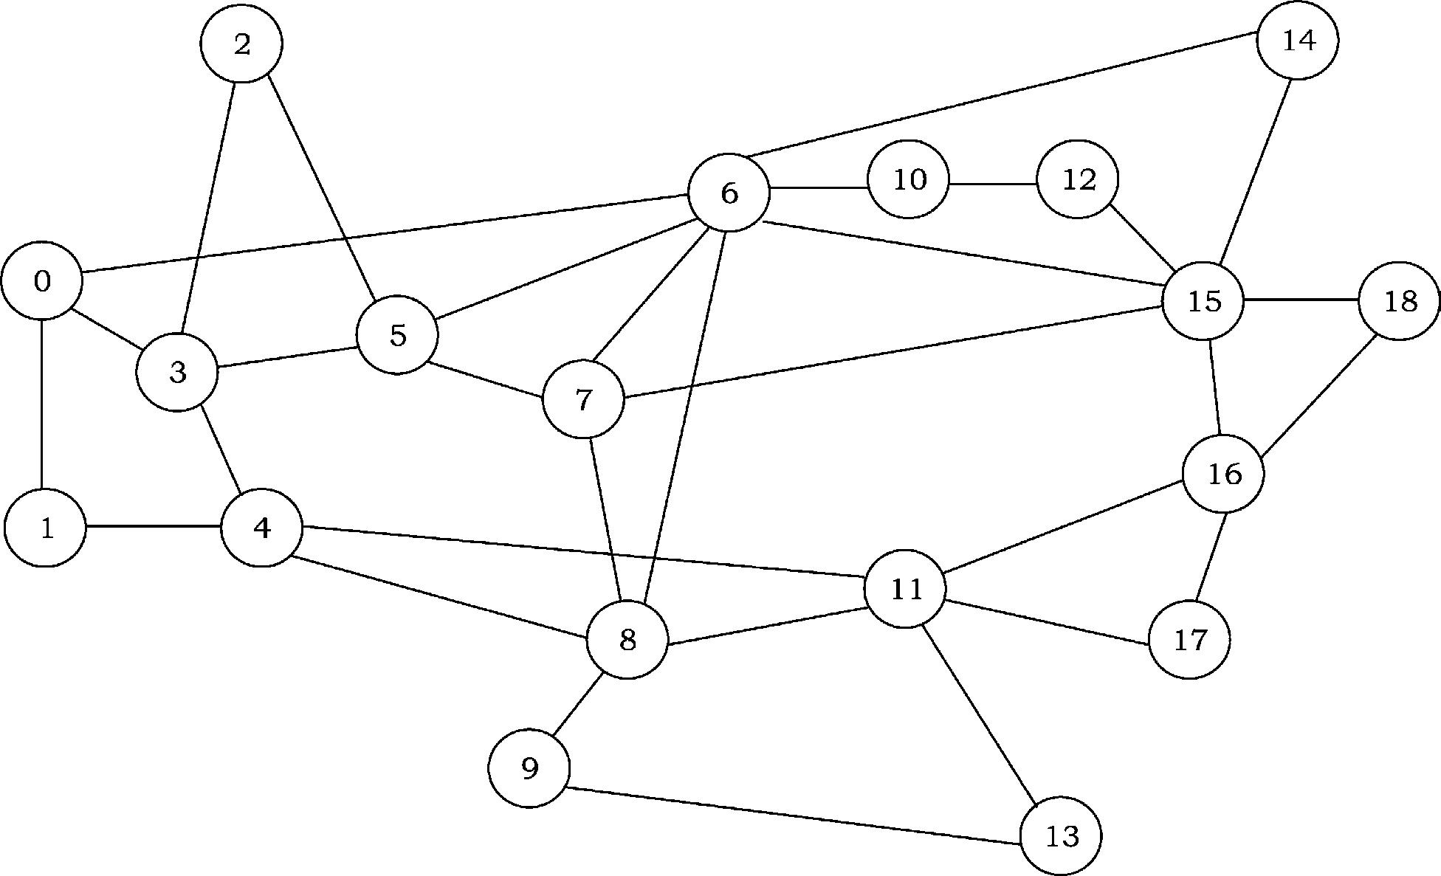
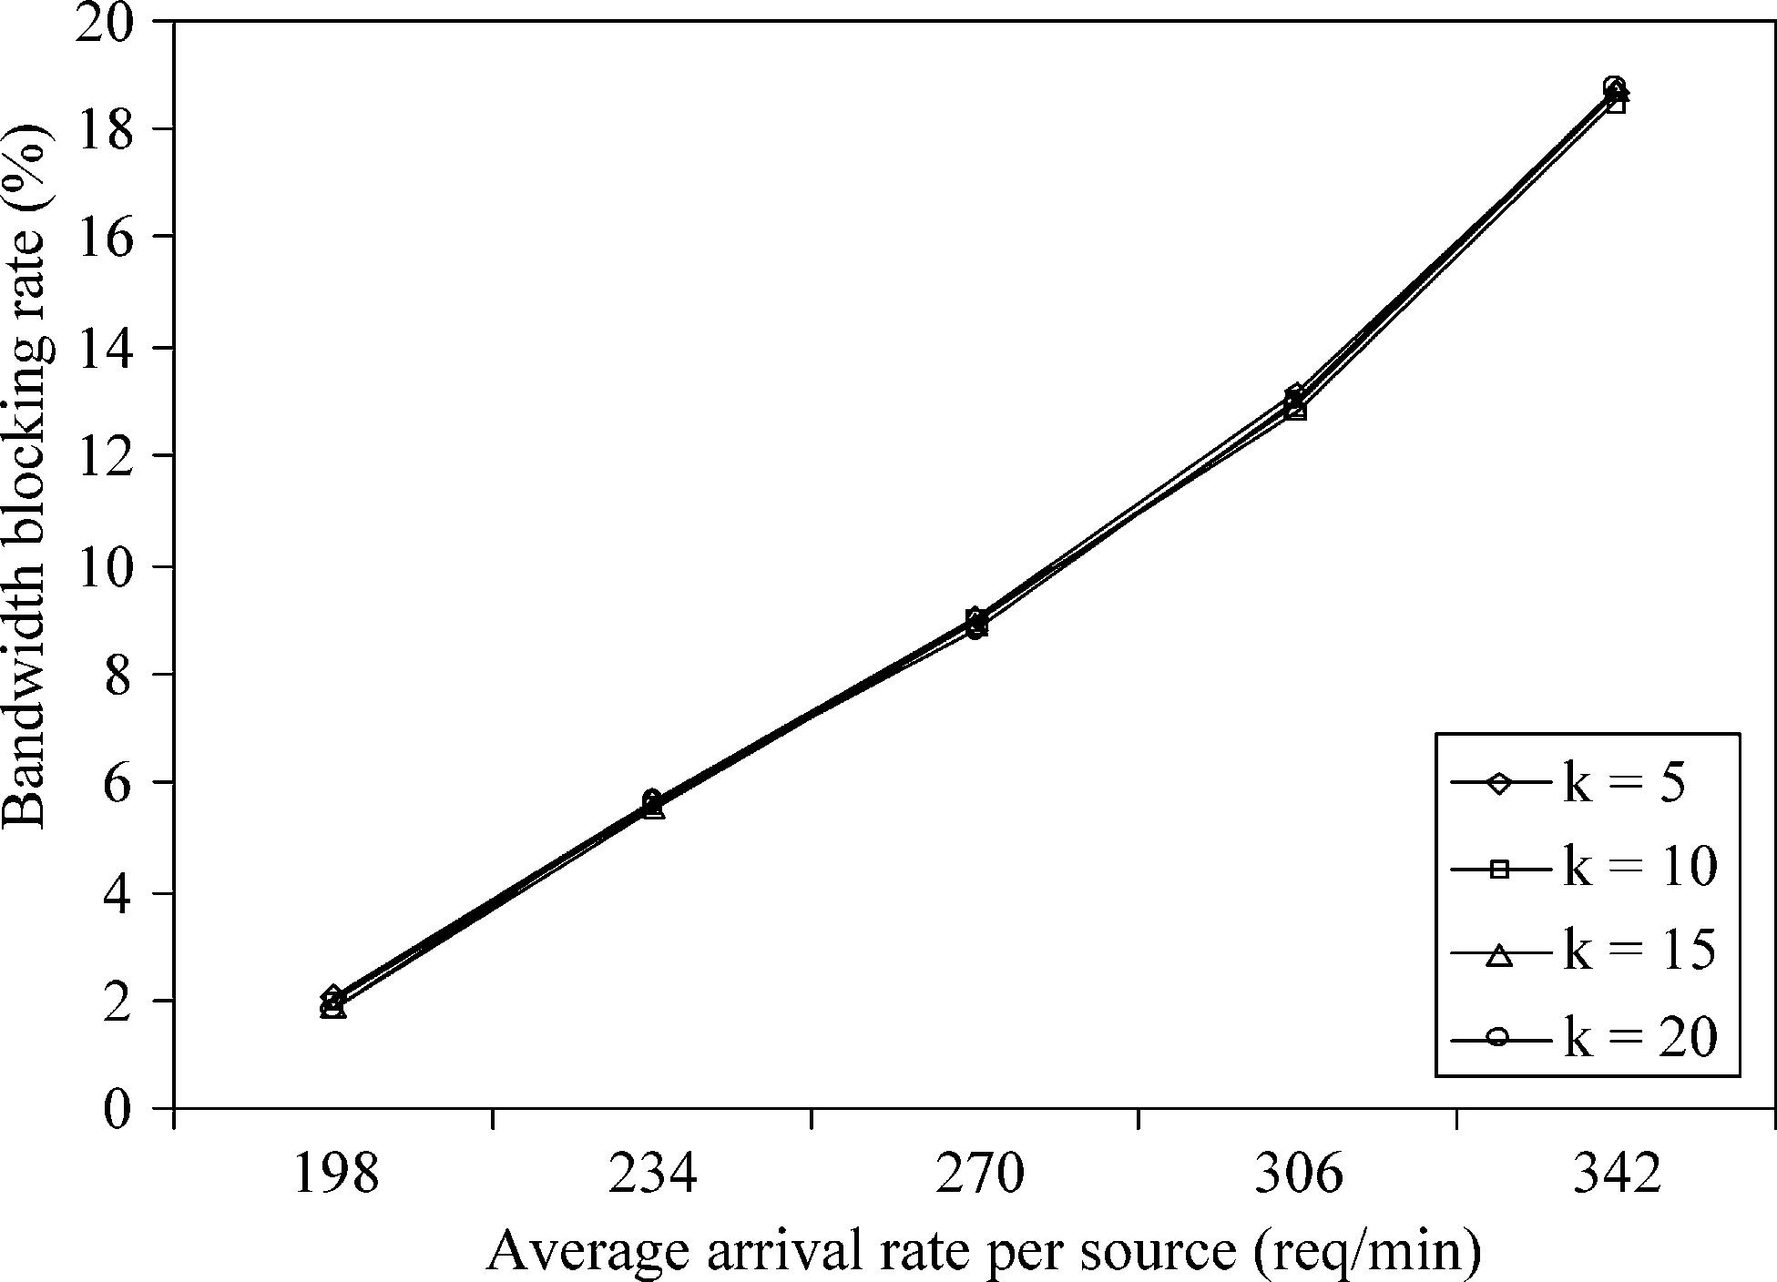
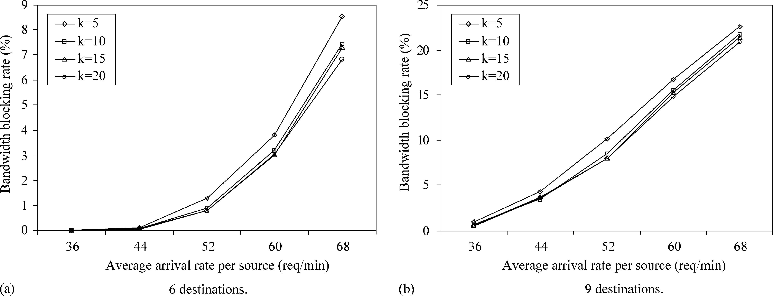

S. Bakiras, V.O.K. Li / Computer Communications 27 (2004) 1330–1340

1337

Fig. 4. The simulated network topology.

Fig. 5. Effect of the number of paths k on the bandwidth blocking rate
(unicast ﬂows).

the service provider will allocate a portion of the available
bandwidth to QoS-sensitive trafﬁc, according to some
policy. This topology represents an autonomous DiffServ
domain, so we have only simulated the intra-domain
resource management scheme. As we have shown in

Section 3.3, inter-domain admission control is performed
as a series of independent intra-domain admission decisions.
New requests may arrive at any one of the 19 routers,
which means that there are N ј 342 different SD pairs. The
new requests arrive at each node i; according to a Poisson
process with mean l_{i}: The arrival rates for the different
nodes are chosen from a uniformly distributed random
variable in the interval Ѕ1; l_{max}: The value of l_{max}is
properly adjusted in order to control the average arrival rate
per node. For unicast ﬂows, we randomly select one node as
the destination, while for multicast ﬂows a ﬁxed number of
destinations are selected (either 6 or 9). The duration of each
connection is exponentially distributed with mean 20 min,
and the required bandwidth is uniformly distributed in the
interval Ѕ100; 1000 kbps. In each experiment we simulate
24 h of real time, and collect the results after an initial
warm-up period. The bandwidth blocking rate is used as the
performance metric, i.e. the percentage of actual bandwidth
that is rejected due to insufﬁcient resources inside the
domain.
In the ﬁrst experiment we investigate the impact of the
number of paths k that are pre-computed for each SD pair.
The results are depicted in Figs. 5 and 6, where we may
observe that setting up more paths per SD pair will generally
result in better performance only in the case of multicast
ﬂows. This result is anticipated, since having a lot of
available paths is important when constructing a shortest
path tree. For unicast ﬂows, the performance is not affected
by the number of paths, since it is always better to route
trafﬁc through shorter paths. Therefore, adding more paths,
which are normally longer, does not reduce the bandwidth
blocking rate.
We then investigate the impact of the reallocation
interval T on the performance of the resource allocation
algorithm. The ‘static’ curve in Figs. 7 and 8 corresponds to
a system where the resource allocation is manually
conﬁgured according to some long term trafﬁc measure-
ments. In the simulation experiments, this curve is produced

Fig. 6. Effect of the number of paths k on the bandwidth blocking rate (multicast ﬂows).

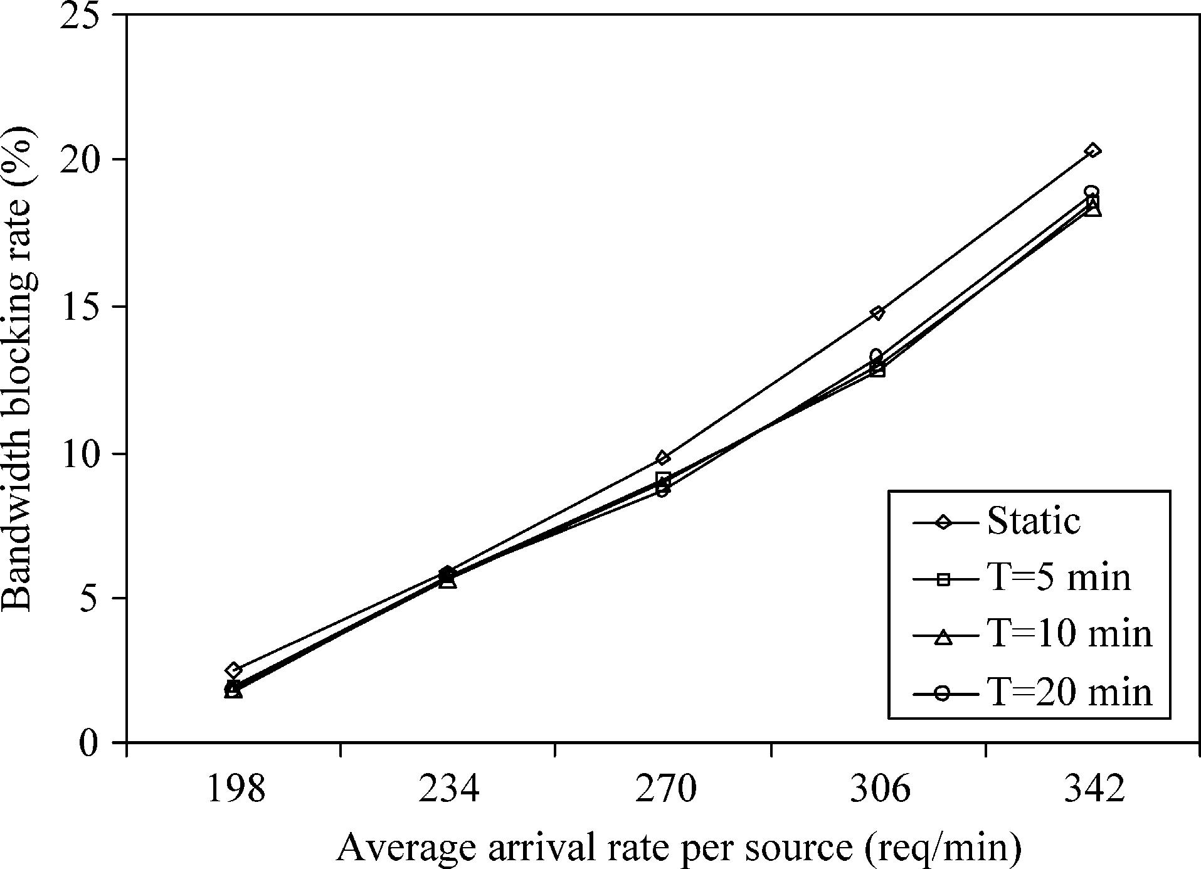
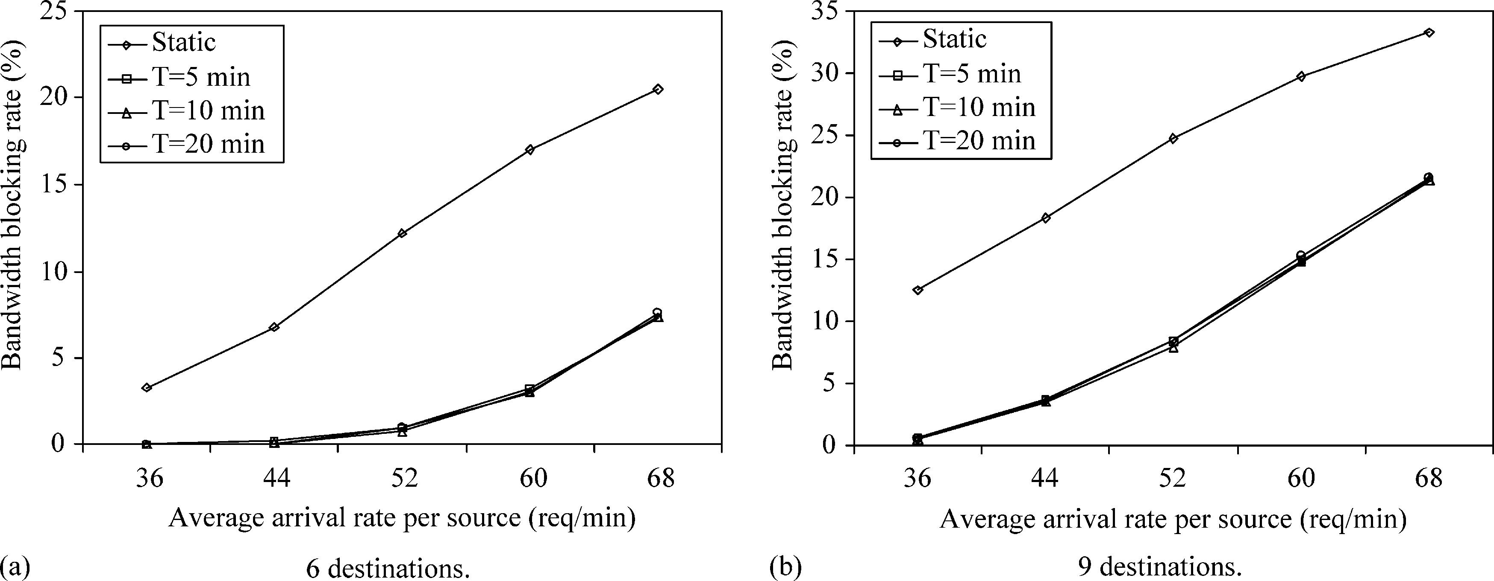
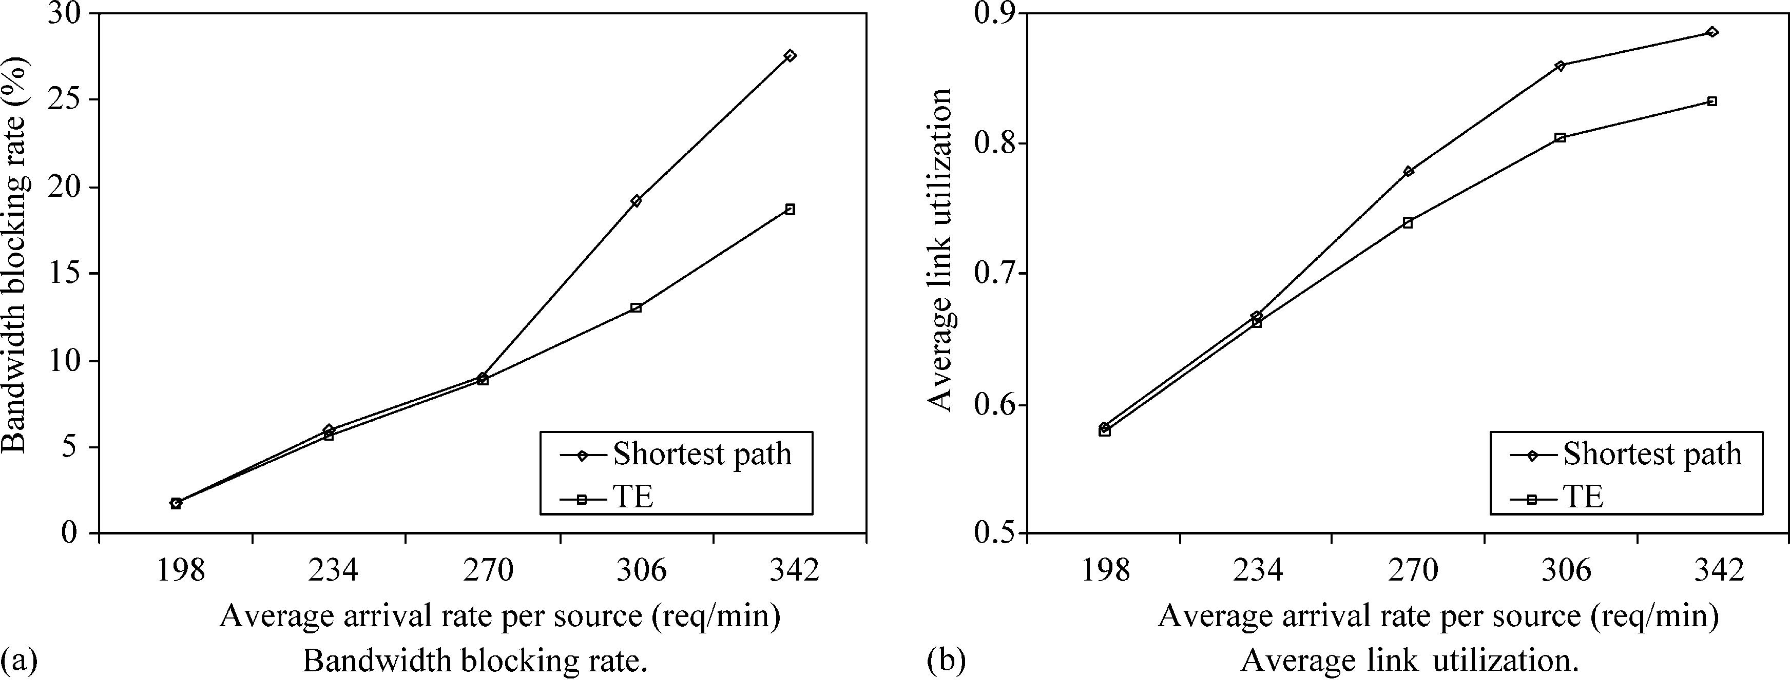

1338

S. Bakiras, V.O.K. Li / Computer Communications 27 (2004) 1330–1340

performance. On the other hand, for multicast ﬂows,
where every new request is destined for a large number of
receivers, the resource reallocation procedure is essential in
order to keep up with the constantly changing trafﬁc
patterns. Another promising result in Fig. 8 is that the
performance of our scheme is not affected by the length of
the measurement window, as long as it is kept at reasonably
small values. Therefore, the control overhead imposed by
the resource reallocation procedure is very low.
Finally, we compare our proposed trafﬁc engineering
mechanism with traditional centralized shortest path rout-
ing. For unicast ﬂows (Fig. 9) our scheme clearly outper-
forms shortest path routing. Its bandwidth blocking rate is
around 10% lower at high trafﬁc loads, while at the same
time it can maintain the average link utilization at lower

Fig. 7. Effect of the reallocation period T on the bandwidth blocking rate
(unicast ﬂows).
by running the resource allocation algorithm at the start of
each experiment (using the known values of l_{i}for each
source), and then using the resulting {x_{i}рl; mЮ} values
for admission control. Notice that for unicast ﬂows,
where the trafﬁc load matrix is relatively stable, the static
and dynamic resource assignment have very similar
levels. This result is quite normal, since shortest path
routing tends to overload the links that belong to the shortest
paths, and further connections have to be established over
longer paths, which consume a lot of the network resources.
For multicast ﬂows (Figs. 10 and 11) the performance of the
two schemes is almost identical, since the construction of a
shortest path tree is more straightforward and involves a
large portion of the network. Notice, that the ‘unicast’ curve

Fig. 8. Effect of the reallocation period T on the bandwidth blocking rate (multicast ﬂows).

Fig. 9. Trafﬁc engineering vs. shortest path routing (unicast ﬂows).

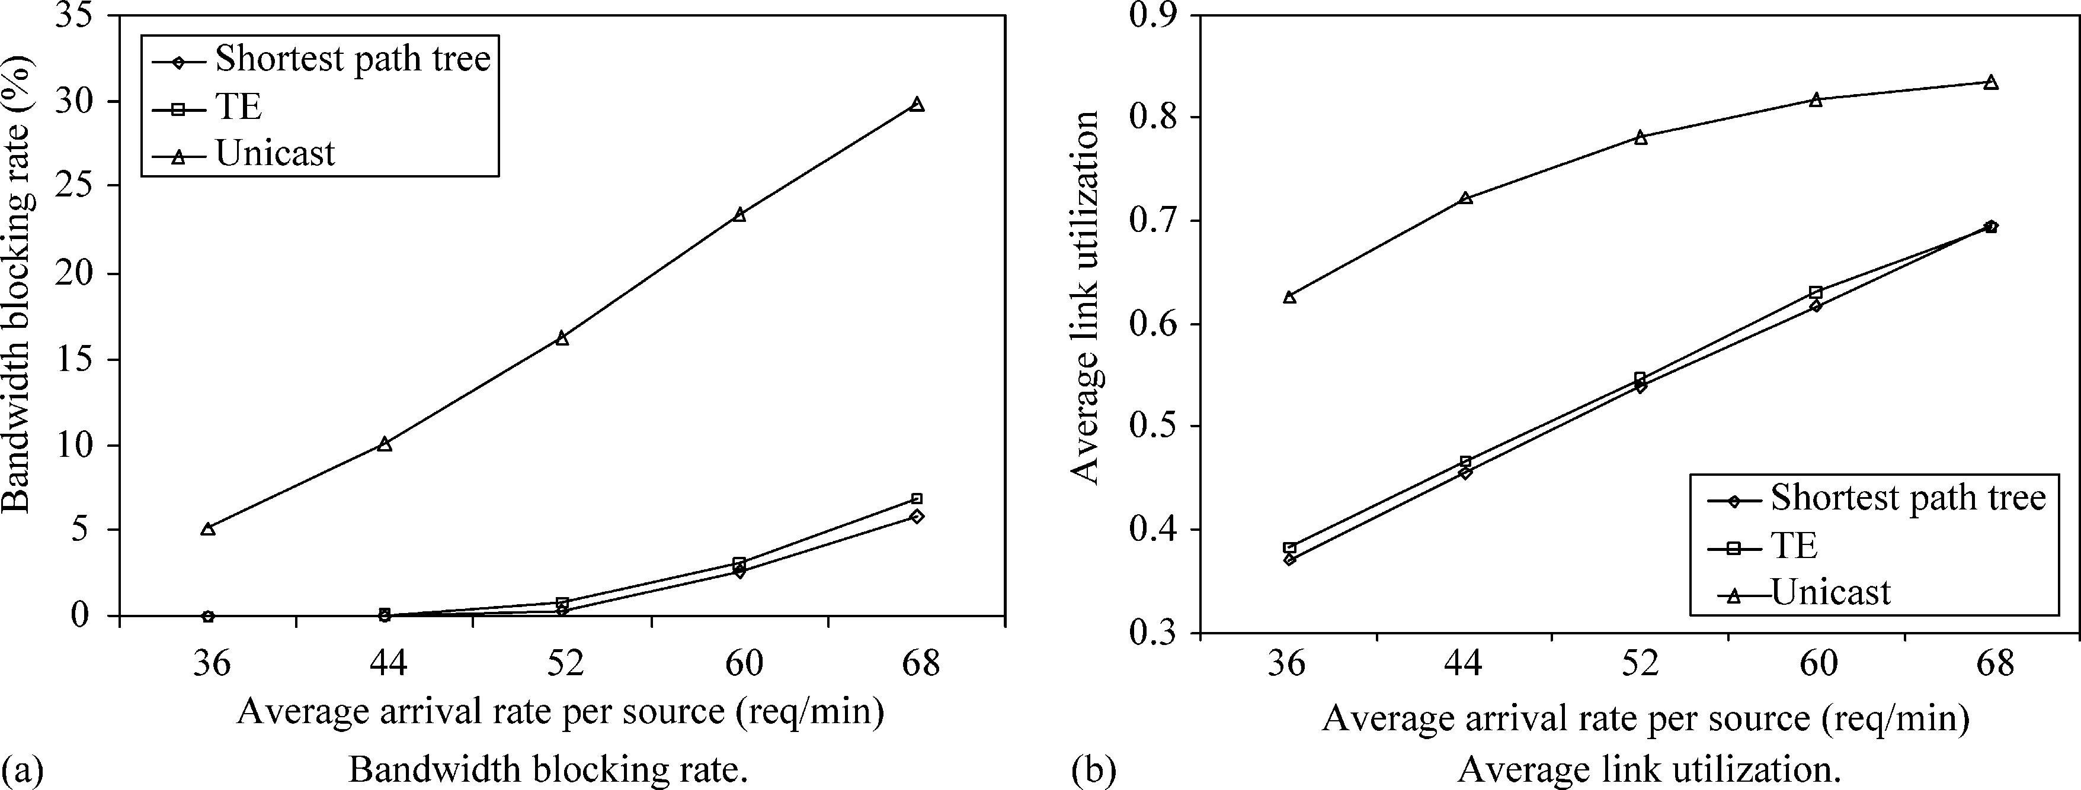
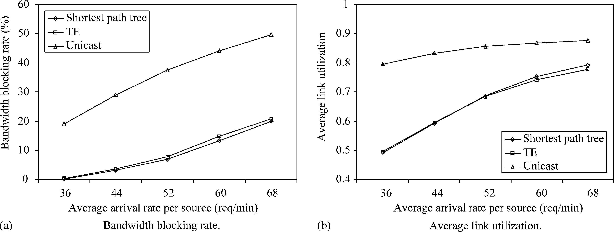

S. Bakiras, V.O.K. Li / Computer Communications 27 (2004) 1330–1340

Fig. 10. Trafﬁc engineering vs. shortest path routing (multicast ﬂows, six destinations).

Fig. 11. Trafﬁc engineering vs. shortest path routing (multicast ﬂows, nine destinations).

1339

corresponds to the case where each multicast request is
served by a number of individual unicast connections. It is
included in these ﬁgures for the purpose of comparison.

5. Conclusions

In this article we proposed a scalable architecture for
providing end-to-end QoS guarantees in DiffServ-based
networks. Our approach enhances the scalability of both the
data and control planes, by pushing most of the functionality
to the edge of the network. Furthermore, we introduced a
trafﬁc engineering mechanism, which periodically updates
the allocation of the resources inside a domain, according to
some measurements of the trafﬁc load at the edge of the
domain. We have shown that the proposed resource
allocation algorithm can manage the network resources
very efﬁciently, leading to lower bandwidth blocking rates
compared to traditional shortest path routing.
We are currently working on the implementation of the
architecture in a small testbed consisting of 19 Linux
routers. Our goal is to test the applicability and performance
of this architecture in an Internet-like environment.
In addition, we will study the impact of QoS-sensitive
ﬂows on the performance of best-effort trafﬁc, and
investigate whether trafﬁc engineering can improve the
average delay experienced by best-effort packets inside a
DiffServ domain.

Acknowledgements

This research is supported in part by the Areas of
Excellence Scheme established under the University Grants
Committee of the Hong Kong Special Administrative
Region, China (Project No. AoE/E-01/99).

References

[1] S. Blake, D. Black, M. Carlson, E. Davis, Z. Wang, W. Weiss, An
architecture for differentiated services, Internet RFC 2475.
[2] K. Nichols, S. Blake, F. Baker, D. Black, Deﬁnition of the
differentiated services ﬁeld (DS ﬁeld) int the IPv4 and IPv6 headers,
Internet RFC 2474.
[3] V. Jacobson, K. Nichols, K. Poduri, An expedited forwarding PHB,
Internet RFC 2598.

1340

S. Bakiras, V.O.K. Li / Computer Communications 27 (2004) 1330–1340

[4] J. Heinanen, F. Baker, W. Weiss, J. Wroclawski, Assured forwarding
PHB group, Internet RFC 2597.
[5] K. Nichols, V. Jacobson, L. Zhang, A two-bit differentiated services
architecture for the Internet, Internet RFC 2638.
[6] B. Teitelbaum, S. Hares, L. Dunn, R. Neilson, V. Narayan, F.
Reichmeyer, Internet2 QBone: building a testbed for differentiated
services, IEEE Network (1999) 8 – 16.
[7] A. Terzis, L. Wang, J. Ogawa, L. Zhang, A two-tier resource
management model for the Internet, in: Proceedings Global
Telecommunications Conference (GLOBECOM), 1999, pp. 1779 –
1791.
[8] C. Chuah, L. Subramanian, R.H. Katz, A.D. Joseph, QoS provisioning
using a clearing house architecture, in: Proceedings International
Workshop on Quality of Service (IWQoS), 2000, pp. 115 – 124.
[9] E. Rosen, A. Viswanathan, R. Callon, Multiprotocol label switching
architecture, Internet RFC 3031.

[10] T. Li, Y. Rekhter, A provider architecture for differentiated services
and trafﬁc engineering (PASTE), Internet RFC 2430.
[11] P. Trimintzios, I. Andrikopoulos, G. Pavlou, P. Flegas, D. Grifﬁn, P.
Georgatsos, D. Goderis, Y. T’Joens, L. Georgiadis, C. Jacquenet, R.
Egan, A management and control architecture for providing IP
differentiated services in MPLS-based networks, IEEE Commun.
Mag. (2001) 80 – 88.
[12] Y. Rekhter, T. Li, A border gateway protocol 4 (BGP-4), Internet RFC
1771.
[13] J.Y. Yen, Finding the K shortest loopless paths in a network, Manage.
Sci. 17 (11) (1971) 712 – 716.
[14] D. Bertsekas, R. Gallager, Data Networks, second ed., Prentice-Hall,
Englewood Cliffs, NJ, 1992.
[15] Q. Ma, P. Steenkiste, On path selection for trafﬁc with bandwidth
guarantees, in: Proceedings International Conference on Network
Protocols (ICNP), 1997, pp. 191 – 202.

